**JINNAH UNIVERSITY FOR WOMEN**

**Department of Computer Science and Software Engineering**

**ENGLISH COMPOSITION AND COMPREHENSION**

**SUMMER CLASS**

**Assignment # 1**

**Name: Ramsha Attaullah khan**

**Class: BS (SE) 2019**

**Submitted to: Ms.Saba**

***“Believe in yourself”***

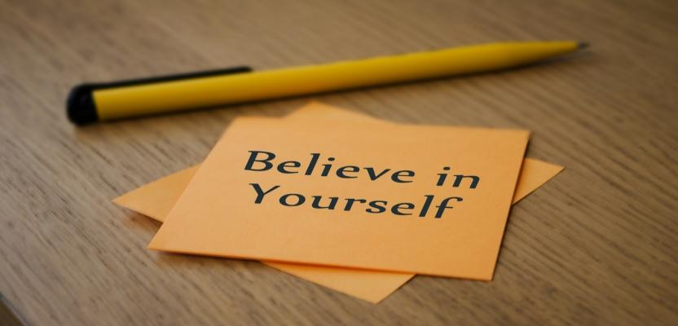

**Believing in oneself** means having **faith** in your own capabilities. It means **believing** that you CAN do something — that it is within your ability. When you **believe in oneself**, you can overcome self-doubt and have the confidence to take action and get things done.

Most people start off with little or low self-confidence, but as a result of their own efforts, they become bold and brave and outgoing. And we’ve discovered that if you do the same things that other self-confident men and women do, you, too, will experience the same feelings and get the same results.

**“Believe in yourself when nobody else does.”**

[**Mary J. Blige**](https://www.brainyquote.com/authors/mary-j-blige-quotes)

The key is to be true to yourself, to be true to the very best that is in you, and to live your life consistent with your highest values and aspirations. This is the only way to truly learn how to believe in yourself.

**“Your success depends mainly upon what you think of yourself and whether you believe in yourself.”**

[**William J. H. Boetcker**](https://www.brainyquote.com/authors/william-j-h-boetcker-quotes)

Take some time to think about who you are and what you believe in and what is important to you.

If you want to change your life by becoming an author, believe that you can do it. The hardest step in that journey is finding the confidence to learn how to write a book. Once you get a hold of a proven system to plan, produce, and publish your work, the larger goal becomes easier to attain.

By believing in yourself, you will find the courage to take immediate action on your goals. And this, as you may know, is the key to success!

I encourage you to never compromise your integrity by trying to be or say or feel something that is not true for you.

And – more importantly – never compromise your potential to grow due to self-limiting doubts. Instead, embrace your confidence and believe in yourself because you really can do anything you put your mind to.

**“Tell Yourself You Have Confidence And Believe It”**

The ability to believe in yourself can change your life.

we can achieve anything if we will just believe in our abilities and work hard through any problems that come our way.

Our beliefs control results – if we don’t believe in something we will never act upon it. We can have the abilities to do many great things but if we don’t have the drive in it then it is all for nothing. You must also have belief not only when we are at the top of our game, but also at the bottom.

Leave no doubt in your mind that you can achieve anything by working on any weak aspects of yourself. Turn them into your strengths. Remove any impossible thoughts or limitations and believe there is a way to achieve anything you desire.

**“I believe that God has put gifts and talents and ability on the inside of every one of us. When you develop that and you believe in yourself and you believe that you're a person of influence and a person of purpose, I believe you can rise up out of any situation.”**

[**Joel Osteen**](https://www.brainyquote.com/authors/joel-osteen-quotes)

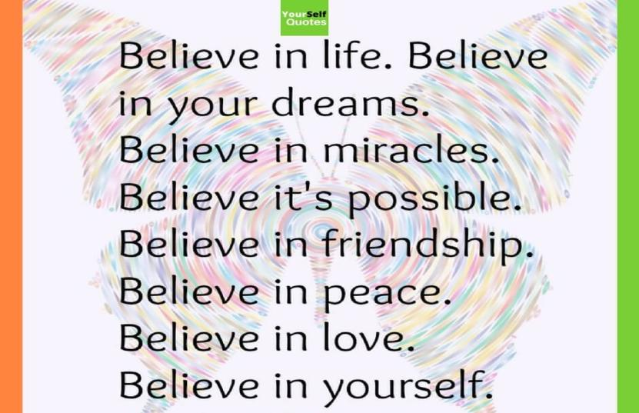

**Repeat affirmations such as “I believe in myself” every day.**

Your thoughts become words and your words become your actions. If you continue to tell yourself that you believe in yourself, eventually you really will believe in yourself.

It’s that simple.

Have the courage to accept yourself as you really are—not as you might be, or as someone else thinks you should be—and know that, taking everything into consideration, you are a pretty good person.

After all, we all have our own talents, skills, and abilities that make us extraordinary.

No one, including yourself, has any idea of your capabilities or of what you might ultimately do or become. Perhaps the hardest thing to do in life is to accept how extraordinary you really can be, believe in yourself, and then to incorporate this awareness into your attitude and personality.